**Hackathon Task Document for E-Commerce Clothing Store**

**Step 1: Choose Your Marketplace Type**

* **Marketplace Type**: General E-Commerce
* **Primary Purpose**:
  1. Provide customers with a seamless shopping experience from the comfort of their homes.
  2. Allow geographical expansion to reach more customers.
  3. Ensure 24/7 accessibility and availability for users.
  4. Increase revenue through direct online sales of budget-friendly clothing.

#### ****Step 2: Define Your Business Goals****

1. **What problem does your marketplace aim to solve?**
   * The store addresses the need for affordable and stylish clothing for men, women, and kids.
   * It offers sizing customization to provide a perfect fit, solving the issue of limited size options available in traditional stores.
2. **Who is your target audience?**
   * Young adults (18–35 years old) and families seeking budget-friendly casual wear with a touch of fashion.
   * Primarily targeting local customers within accessible delivery zones.
3. **What products or services will you offer?**
   * A comprehensive range of casual clothing for men, women, and kids.
   * Products include T-shirts, jeans, dresses, and trendy fashion items at affordable prices.
   * Sizing customization for customers to ensure a perfect fit.
4. **What will set your marketplace apart?**
   * Affordable pricing without compromising on quality.
   * Sizing customization options for better customer satisfaction.

#### ****Step 3: Create a Data Schema****

1. **Entities in Your Marketplace**:
   * **Products**: Clothing items available for sale.
   * **Orders**: Transactions between customers and the platform.
   * **Customers**: Individuals purchasing products.
   * **Delivery Zones**: Areas covered by delivery services.
   * **Shipments**: Tracking the movement of orders from warehouse to customer.
   * **Payments**: Transactions and payment status records.
2. **Relationships Between Entities**:

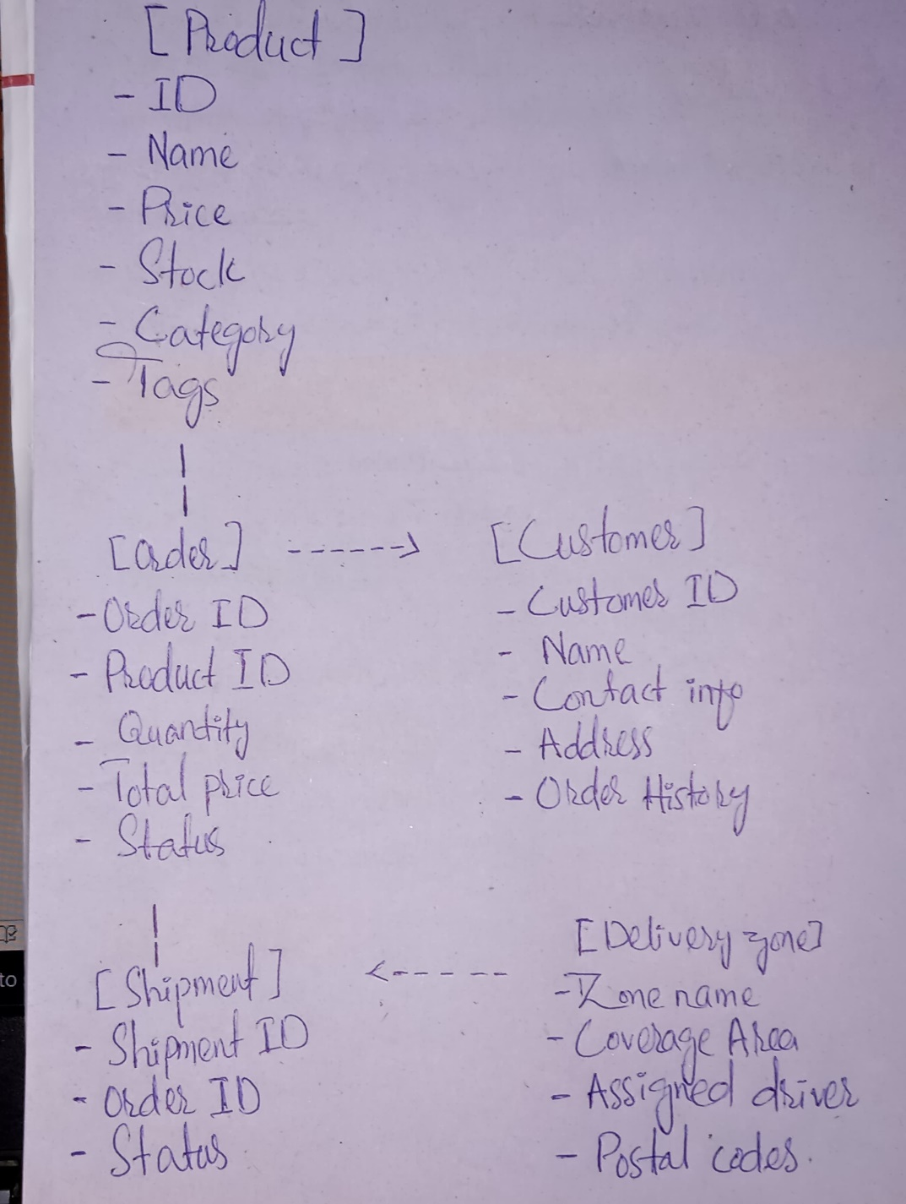

1. **Key Fields for Each Entity**:

**Products**:

* + ID: Unique identifier for each product.
  + Name: Product name (e.g., “Men’s Casual T-Shirt”).
  + Price: Cost per unit.
  + Stock: Quantity available.
  + Category: Men’s, Women’s, Kids.
  + Tags: Keywords for search (e.g., “New Arrival”).

**Orders**:

* + Order ID: Unique identifier for each order.
  + Customer Info: Name, contact details, and address.
  + Product Details: List of products, quantities, and total price.
  + Status: Current status (Pending, Shipped, Delivered).
  + Timestamp: Date and time of order placement.

**Customers**:

* + Customer ID: Unique identifier.
  + Name: Full name.
  + Contact Info: Phone number and email address.
  + Address: Delivery address.
  + Order History: Previous orders placed by the customer.

**Delivery Zones**:

* + Zone Name: Name of the delivery zone.
  + Coverage Area: List of postal codes or cities served.
  + Assigned Drivers: Details of delivery personnel.

**Shipments**:

* + Shipment ID: Unique identifier for tracking.
  + Order ID: Linked order.
  + Status: Current shipment status (In Transit, Delivered).
  + Delivery Date: Expected or actual delivery date.

**Payments**:

* + Payment ID: Unique identifier.
  + Order ID: Linked to the relevant order.
  + Payment Status: Paid, Pending, Failed.
  + Payment Method: COD, Credit Card, etc.

1. **Validation with Business Goals**:
   * Ensures affordable and customizable clothing options for customers.
   * Focused on efficient order tracking, inventory management, and customer satisfaction.
   * Flexible for future expansion to include additional categories like accessories or footwear.

#### 